CIC Meeting Room Booking Form 2025

(Please type or print)
Name of Company

Contact Name Conference Registration Number

Address

City State Zip Code Country

Business Phone Fax Number Email Address

Date required: June 2 June 3
Meeting Room Rate: US$1500.00

Total amount to be charged:

REMITTANCE DETAILS

Please provide credit card information to confirm and guarantee your Meeting Room.

Visa 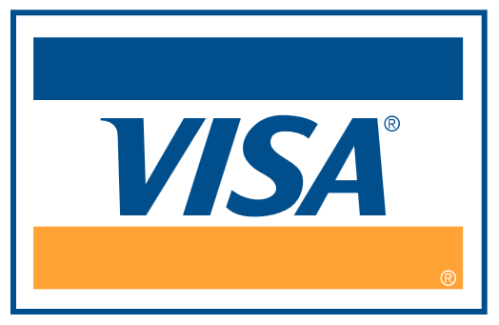 Master Card 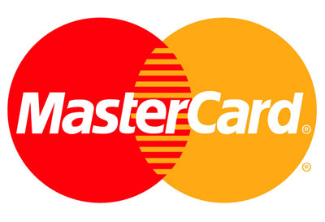 AMEX *

*(please note that AMEX transactions incur

an additional 5% service fee)*

Cheque/Bank Draft/Wire Transfer (Please include a copy of actual cheque or bank transaction details to secure booking)

Card Number Expiry Date (Month/Year)

Cardholder’s Name Signature

_________________________________________
Cardholder’s Address

All cheques should be in US dollars drawn on a US bank and payable to Insurance Association of the Caribbean Inc.,
Thomas Peirce Building, Lower Collymore Rock, St. Michael, Barbados, West Indies.
Tel: (246) 427-5608/09 Fax: (246) 427- 7277

Email: conference@iac-caribbean.com

CANCELLATION POLICY
Any cancellation of Meeting Rooms will be refunded less US$100.00 if received on or before April 30, 2025. Any Cancellations received after April 30, 2025, will NOT be refunded any part of the meeting room fee.

