Caribbean Insurance Conference 2025

ADVERTISING CONTRACT

Conference Magazine

Type of Advertising Placed

Full Colour  

Size of the ad
Full Page Half Page Quarter Page

Name of the Company

Name of Contact

Invoicing Address

Telephone Fax Email

IAC Member  LIMRA/LOMA Member IAC and LIMRA/LOMA Member Non-Member

TERMS & CONDITIONS
1. The Total amount of $ shall be made payable to the Insurance Association of the Caribbean, Inc.

2. Full payment must accompany your order. Payment can be made in the form of cash, cheque or VISA and Master Card credit cards.

3. For Credit card payment, please complete the following:
VISA 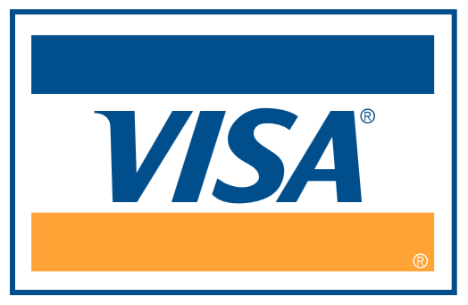 MASTERCARD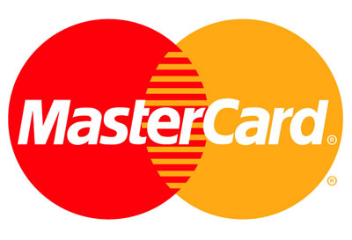 *AMEX * *(please note that AMEX transactions incur

an additional 5% service fee)*

Card No Expiry Date:

…………………………………

Cardholder’s Signature

Wire Transfer Cheque/Bank Draft (Kindly provide confirmation of transaction)

Wire Transfer Details:

Wire Transfer Details (US Account)

Beneficiary Name: Insurance Association of the Caribbean

Beneficiary’s Address: The Mutual Trans-Nemwil Building, The Villa. St George, Grenada

Beneficiary’s Bank Name: Grenada Co-operative Bank Limited

Beneficiary’s Bank Address: 8 Church Street, St. George, Grenada

Beneficiary’s Bank SWIFT Address: GROAGDGD

Beneficiary’s Bank Account#: 107040770

N.B -No intermediary bank is required.

ADVERTISER’S AGREEMENT
I agree to place an advertisement in the Caribbean Insurance Conference 2025 Magazine.
Cost of Advertising $(US)
I understand that it is the responsibility of the Advertisers to provide camera-ready artwork by March 29, 2025.

Signed: Print Name:
Date: On behalf of:

NB. If for any reason the above conditions are not met by the given deadline, the IAC reserves the right to print, ‘with compliments of’ along with your company’s name and address, in the space authorised above at the set cost.

Please provide artwork to:
Insurance Association of the Caribbean Inc.
The Thomas Peirce Building, Collymore Rock,
St. Michael
Barbados, West Indies.
Tel (246) 427-5608/09 Fax: (246) 427-7277
Email: conference@iac-caribbean.com

The magazine will be distributed electronically this year.

Additional Advertising Information

- SPECIAL DISCOUNTS
10% discount to Caribbean owned companies and for all IAC members who are financial at January 31, 2025 as well as to LIMRA/LOMA members.

DEADLINES
Close off for booking March 22, 2025

ARTWORK DEADLINE
March 29, 2025

- ARTWORK SPECIFICATIONS
Advertisement Dimensions
- Actual Magazine Size 8.5” wide x 11” high
- Full Page Ad 7” wide x 9.375” high
- Full Page Bleed 8.75” wide x 11.25” high

Any copy should fall within the full-page size of 7” wide by 9.375” high on all full-page bleed ads.

Half page Horizontal 7” wide x 4.625” high
Half page vertical 3.375”wide x 9.375”high
¼ page vertical 3.375” wide x 4.625” high

Pre-Press Material Required
Only Electronic Files on Disc 100 MB pr 250 MB Zip, 1GB jaz or CD, will be accepted.
Please create all artwork in Adobe Illustrator, Macromedia Freehand, Adobe Photoshop or Quark Xpress. Freehand, Illustrator or Quark files must be supplied as EPS. Original Quark documents must also be included with the EPS Version as well as all fonts and any imported pictures or illustrations. Illustrator, Freehand and Photoshop files must all be supplied with fonts as outlines. If fonts cannot be converted to outlines, please include all Printer and Screen Fonts. All colours in all files must be converted to CMYK. Please do not specify and any colours as Pantone or RGB. Any pictures included in any of the above formats must be of at least 300dpi. Please ensure all placed images are linked.

No Corel Draw files will be accepted.

A HIGH RESOLUTION COLOUR PROOF OR 720DPI POSTSCRIPT CORRECT PRINTOUT OF THE AD MUST BE SUPPLIED WITH THE ARTWORK.

Advertising Rates

Covers
Back Cover US$2250.00
Front Inside Cover US$1920.00 RESERVED
Back Inside Cover US$1920.00

Full Colour Inserts
Full Page US$1810.00
Half Page US$1260.00
¼ Page US$900.00

The above rates are for camera-ready artwork and do not include the cost of developing artwork. IAC can have your ad created or recreated for you at a reasonable cost. Please specify at the time of booking if this service is to be included in the billing.

SPECIAL CHARGES
10% discount to Caribbean owned companies and IAC and LIMRA/LOMA member companies

DEADLINES
Booking Deadline
Close off for booking - March 22, 2025

Artwork Deadline
March 29, 2025

